PREDICTOR –CORRECTOR METHODS:
The methods which we have discussed so for are called single-step methods because they use only the information from the last step computed. The methods of Milne’s predictor-corrector, Adams-Bashforth predictor corrector formulae are multi-step methods.
In solving the equation = f(x,y), y(x₀) = y₀ we used Euler’s formula.
y_{i+1} = y_{i} +hf’(x_{i},y_{i}) , i = 0,1,2……. -------------(1)
We improved this value by Improved Euler method
y_{i+1} = y_{i} +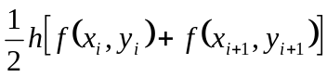 -------------(2)
In the equation (2), to get the value of y_{i+1} we require y_{i+1} on the R.H.S. To overcome this difficulty, we calculate y_{i+1} using Euler’s formula (1) and then we use it on the R.H.S of (2), to get the L.H.S. of (2). This y_{i+1} can be used further to get refined y_{i+1} on the L.H.S. Here, we predict a value of y_{i+1} from the rough formula (1) and use in (2) to correct value. Every time , we improve using (2). Hence equation (1) Euler’s formula is a predictor and (2) is a corrector. A predictor formula is used to predict the value of y at x_{i+1} and a corrector formula is used to correct the error and to improve that value of y_{i+1}.
MILNE’S PREDICTOR AND CORRECTOR METHOD:
FORMULA:
Predictor:
y_{n+1,p} = y_{n-3}+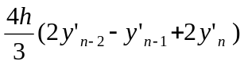
Corrector:
y_{n+1,c} = y_{n-1}+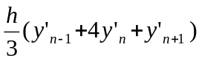

PROBLEMS:
- Find y(2) if y(x) is the solution of 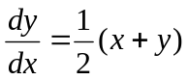given y(0) = 2, y(0.5) = 2.636,
y(1) = 3.595 and y(1.5) = 4.968, Using Milne’s method.
Sol:
Here, h = 0.5, x₀= 0, y₀ = 2, x₁= 0.5, x₂ = 1.0, x₃ = 1.5, x₄ = 2.0, y₁ = 2.636, y₂= 3.595 ,
y₃= 4.968, f(x,y) = 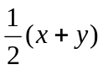= y’
By Milne’s predictor formula,
y_{n+1,p} = y_{n-3}+
y_{4,p} = y₀+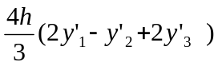 ……………..(1)
Here,
y₁’=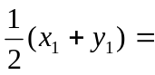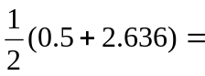1.5680
y₂’ = 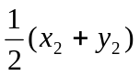= 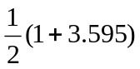= 2.2975
y₃’= 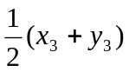= 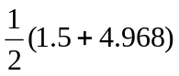= 3.2340
By(1),
y_{4,p} = 2+ 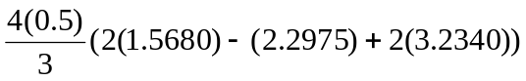
= 6.8710
Using Milne’s corrector formula,
y_{n+1,c} = y_{n-1}+
y_{4,c} = y₂+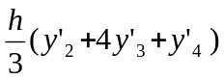 …………….(2)
y₄’= 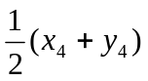= 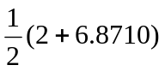= 4.4355
Using (2),we get
y_{4,c} = 3.595+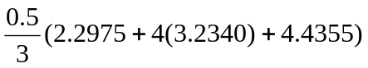
= 6.8732.

- Using Milne’s method, find y(4.4) given 5xy’+y²-2 = 0 given y(4) = 1, y(4.1) = 1.0049, y(4.2) = 1.0097, and y(4.3) = 1.0143.
Sol:
Here, h =0.1, x₀= 4, y₀ =1, x₁= 4.1, x₂ = 4.2, x₃ = 4.3, x₄ = 4.4, y₁ = 1.0049, y₂= 1.0097,
y₃= 1.0143, f(x,y) = 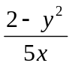= y’
By Milne’s predictor formula,
y_{n+1,p} = y_{n-3}+
y_{4,p} = y₀+ ……………..(1)
Here,
y₁’==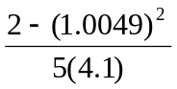=0.0493
y₂’ = = 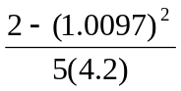= 0.0467
y₃’= = 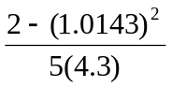= 0.0452
By(1),
y_{4,p} = 1+ 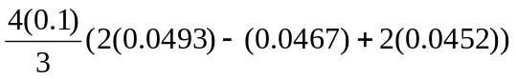
= 1.01897
Using Milne’s corrector formula,
y_{n+1,c} = y_{n-1}+
y_{4,c} = y₂+ …………….(2)
y₄’= = 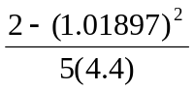= 0.0437
Using (2),we get
y_{4,c} = 1.0097+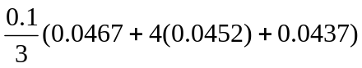
= 1.01874.

